Operating Manual

The wood console have a tax cross on the left side and four action buttons (a,b,x and y) on the right side.   
Power button for booting or shutting down the console.   
Load the start picture. Have the console battery and you can in the menue.   
The menu have some options, it is about tax cross to choose.   
You can confirm the option with action button “a”.

Bomberman  
The tax cross is for movement responsible for the character.  
Action button “b” settles the bombs.

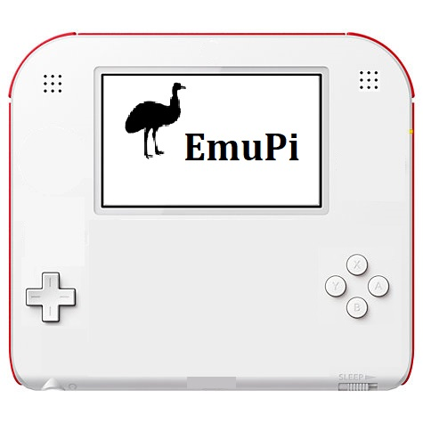

Power on/off

**P**

Audio

Audio

Select

Start

Display

Action buttons

Tax cross